Mini Project - Golf

Table of Contents
1. Project Objective 3
2. Assumptions 3
3. Exploratory Data Analysis – Step by step approach 3
1. Environment Set up and Data Import 4
2. Variable Identification 4
3. Univariate Analysis 9
4. Bi-Variate Analysis 9
5. Missing Value Identification 9
6. Outlier Identification 9
7. Variable Transformation / Feature Creation 9
4. Conclusion 9
5. Appendix A – Source Code 10

Project Objective
The objective of the report is to explore the Golf ball data set (“Golf.csv” ) in R and generate insights about the dataset. This exploration report consists of the following:
- Importing the data set in R
- Understanding the structure of the data set
- Graphical exploration
- Descriptive statistics
- Insights from the dataset

- Assumptions
Since, we are going to measure the difference between two means of the two groups in the given data set, we assume, two sample t test would be appropriate to test the data. The assumptions of the two sample t test are mentioned below.
- The data is continuous
- The data follow the normal distribution
- The variances of two samples are equal
- The two samples are independent
- Both the samples are simple random samples from their respective populations
meaning, each individual in the population has an equal probability of being
selected in the sample.

Exploratory Data Analysis – Step by step approach
A typical data exploration activity consists of the following steps:

- Environment set up and Data import
- Variable identification
- Univariate Analysis
- Bi-Variate Analysis
- Missing value treatment (Not in scope of our project)
- Outlier Treatment (Not in scope of our project)
- Variable Transformation / Feature Creation
- Feature Exploration

We shall follow these steps in exploring the given data set.
Although Steps 5 and 6 are not in scope for this project, a brief about these steps (and other steps as well) is given, as these are important steps for Data Exploration journey.

Environment Set up and Data Import
    - Install necessary packages and invoke libraries
Use this section to install necessary packages and invoke associated libraries. Having all the packages at the same places increases code readability.
    - Set up Working Directory
Setting a working directory on starting of the R session makes importing and exporting data files and code files easier. Basically, working directory is the location/ folder on the PC where you have the data, codes etc. related to the project.
Please refer Appendix A for Source Code.
    - Import and Read the Dataset
The given dataset is in .csv format. Hence, the command ‘read.csv’ is used for importing the file. Please refer Appendix A for Source Code.
#Read the input file
golf = read.csv("Golf.csv")
attach(golf)

Variable Identification
#Find the internal structure of the data
str(golf)
#Find the descriptive statistics of the data
summary(golf)
#Test if the two samples are normally distributed
#Draw a box plot for comparing Current Ball and New Ball samples
boxplot(CurrentBall, NewBall, horizontal = TRUE,names = c("Current Ball", "New Ball"), main="Comparative box plot of New Ball and Current ball Data")
# Draw historgram for Current Ball group
hist(CurrentBall)
# Draw historgram for New Ball group
hist(NewBall)
# Use var.test function to check the equality of variances.
var.test(CurrentBall, NewBall, alternative = "two.sided")
# Calculate the p-value using 2 sample t test to compare the driving distances of
# Current and new golf ball data in the given data set
t.test(CurrentBall, NewBall, alternative = "two.sided", mu=0, paired=FALSE, var.equal=TRUE, conf.level = 0.95)
#Calculate the 95% confidence Interval for the population of Current Ball
t.test(CurrentBall)
#Calculate the 95% confidence Interval for the population of New Ball
t.test(NewBall)
#Calculate the Standard Deviation of Current Ball Data
sd(CurrentBall)
#Calculate the Standard Deviation of New Ball Data
sd(NewBall)
#Find the Standard Deviation of difference of the two means of the data
SD=sd(NewBall - CurrentBall)
# Find the true difference in the means of two samples
delta = mean(CurrentBall) - mean(NewBall)
#Calculate the power of t test with the default value of beta=0.1(probability of type II error)
power.t.test(power = 0.9, delta = delta, sd=SD, sig.level = 0.05, type = "two.sample", alternative = "two.sided" )
    - Variable Identification – inferences
#Find the descriptive statistics of the data
summary(golf)

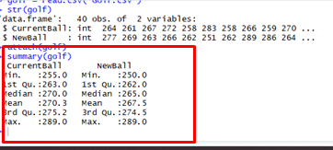
boxplot(CurrentBall, NewBall, horizontal = TRUE,names = c("Current Ball", "New Ball"), main="Comparative box plot of New Ball and Current ball Data")
- As per the box plot, both the samples are independent of each other
- As per the box plot, the mean and median are almost same for both the groups
- Hence, we can assume that each group data is normally distributed

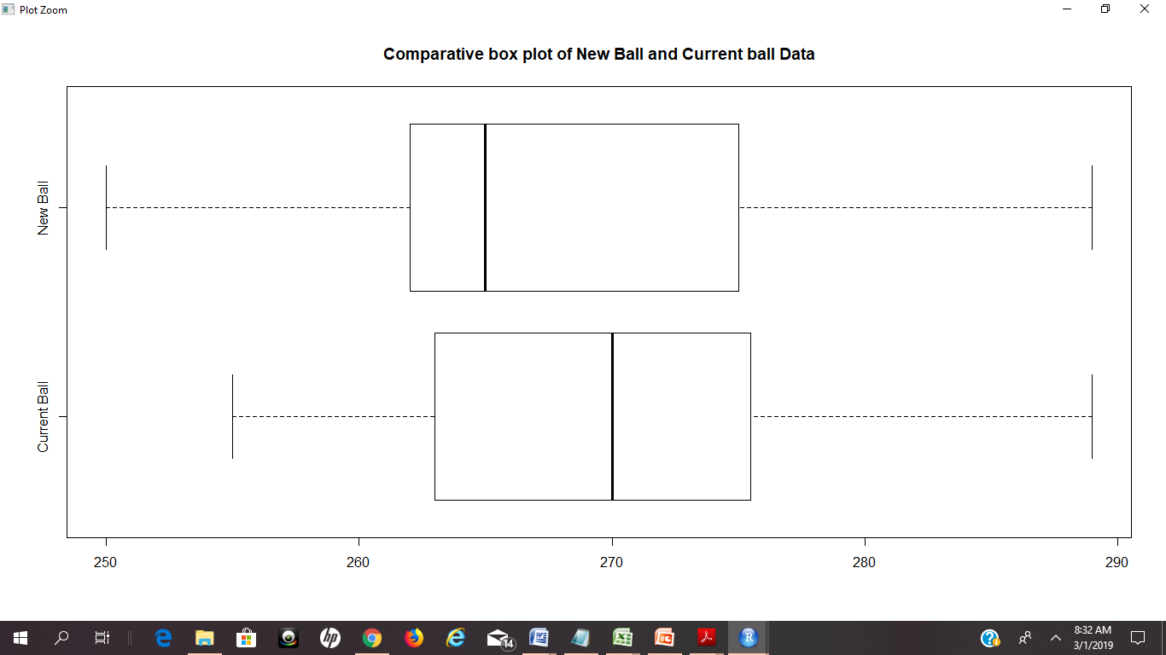
hist(CurrentBall)
hist(NewBall)
- As per the histograms, data seems to be normally distributed
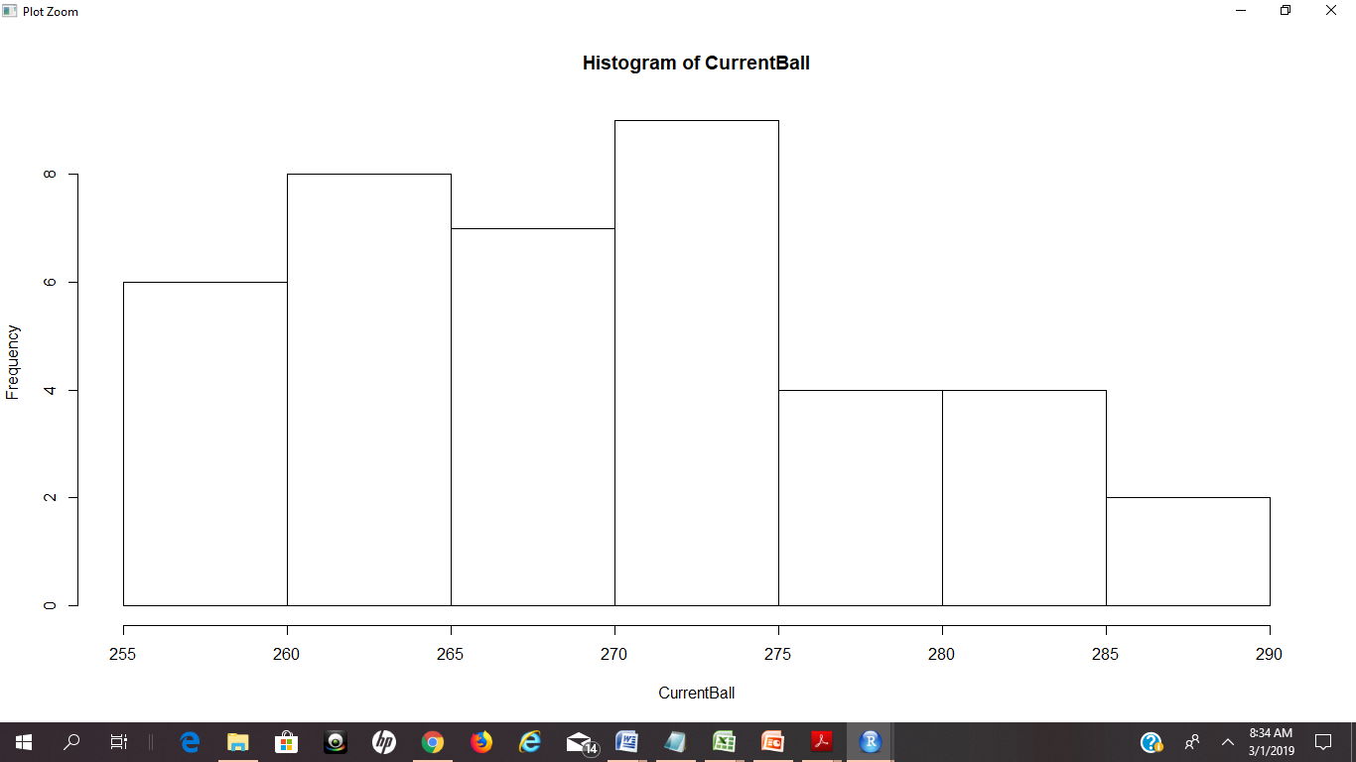

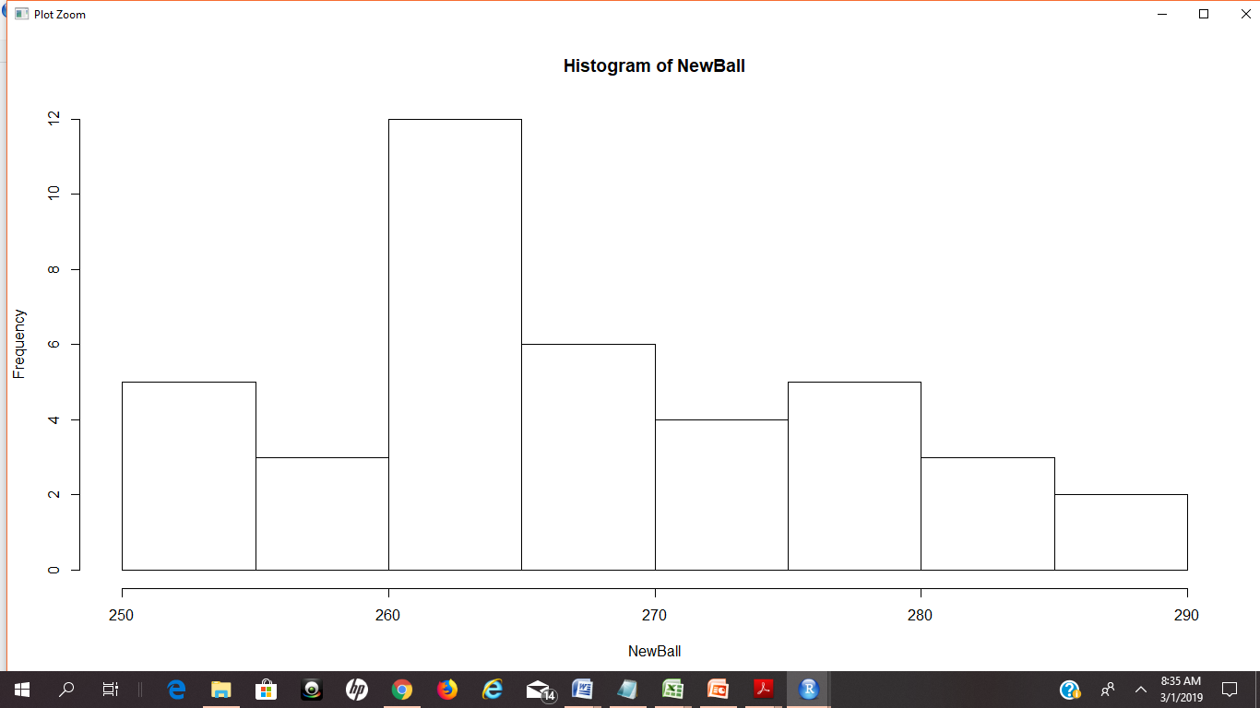
# Use var.test function to check the equality of variances.
var.test(CurrentBall, NewBall, alternative = "two.sided")
Null Hypothesis, H0 = Variance of Current Ball = Variance of New Ball
Alternate Hypothesis Ha = Variance of Current Ball != Variance of New Ball
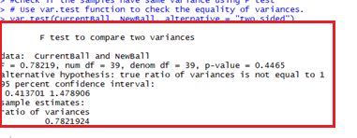
- Since p-Value of 0.4465 is > 0.05, we fail to reject the null hypothesis
Hence both the variances are equal.

# Calculate the p-value using 2 sample t test to compare the driving distances of Current and new golf ball data in the given data set
Null Hypothesis H0= Mu New - Mu Curr = 0
Alternate Hypothesis Ha = Mu New - Mu Curr != 0
t.test(CurrentBall, NewBall, alternative = "two.sided", mu=0, paired=FALSE, var.equal=TRUE, conf.level = 0.95)
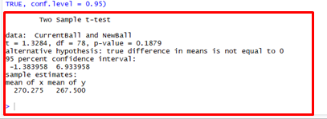
- Since p-value 0.1879 > 0.05, we fail to reject the null hypothesis
Hence, we conclude that, there is no considerable difference between the two means of data to prove that the new coating has effect on the driving distances of golf balls.
- 95 percent confidence interval for the difference between the means of the population is: -1.383958 6.933958
#Calculate the 95% confidence Interval for the population of Current Ball
t.test(CurrentBall)
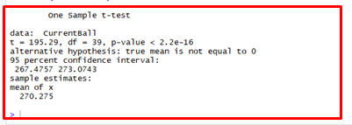
- 95 percent confidence interval:267.4757 273.0743

#Calculate the 95% confidence Interval for the population of New Ball
t.test(NewBall)
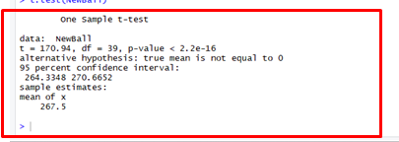
- 95 percent confidence interval:264.3348 270.6652

#Calculate the power of t test with the default value of beta=0.1(probability of type II error)
power.t.test(power = 0.9, delta = delta, sd=SD, sig.level = 0.05, type = "two.sample", alternative = "two.sided" )
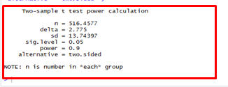

- The power of the test is the probability that we make the right decision when the null is not correct.
- The above result shows that, we need a sample size of 517 (rounded to the next whole number) to make the right decision about the golf balls.

Univariate Analysis
<Explore individual variables one by one>
<Present your findings in tabular format>
<Summarise key observations about each variable>

Bi-Variate Analysis
<To Explore relationship between two variables>
<Interpret the findings>

Missing Value Identification
<See if any missing values>

Outlier Identification
<See if any outliers>

Variable Transformation / Feature Creation
<Do you see a need of transforming a variable/ creating new variables for better understanding of the data, or presenting the results to the customer?>
<Act accordingly>

Conclusion
- Since p-value 0.1879 > 0.05, we fail to reject the null hypothesis. Hence, we conclude that, there is no considerable difference between the two means of data to prove that the new coating has effect on the driving distances of golf balls.
- The power of the test with the default probability of 0.1(Default probability of type II error) shows that, we need a sample size of 517 balls in each group to make the right decision about the golf balls.

Appendix A – Source Code
